**Question 15.2 .1**

In the videos, we saw the “diet problem”. (The diet problem is one of the first large-scale optimization

problems to be studied in practice. Back in the 1930’s and 40’s, the Army wanted to meet the nutritional

requirements of its soldiers while minimizing the cost.) In this homework you get to solve a diet problem with real data. The data is given in the file diet.xls.

Formulate an optimization model (a linear program) to find the cheapest diet that satisfies themaximum and minimum daily nutrition constraints, and solve it using PuLP. Turn in your codeand the solution. (The optimal solution should be a diet of air-popped popcorn, poached eggs,oranges, raw iceberg lettuce, raw celery, and frozen broccoli. UGH!)

**Answer:** Given below is the solution to the problem

Based on the nature of the question, here is how we interpret the data

**DATA**

cj = Cost per j unit of food

aij = Total nutrient I per unit food j

mi = Minimum amount of each nutrient i required daily

Mi = Maximum amount of each nutrient i required daily

Given below would be the variables

**VARIABLES**

xj = amount of food j eaten

Given below would be the constraints expressed in English and its mathematical expression

**CONSTRAINTS**

1. Consume atleast minimum amount of each nutrient. So total nutrient consumption would greater than or equal to mi.
2. Consume atmost maximum amount of each nutrient. So total nutrient consumption would less than or equal to Mi.
3. Some amount of food has to be eaten. Food eaten should be greater than xj.

**CONSTRAINTS MATHEMATICAL EXPRESSION:**

1. ∑j aijxj ≥ mi for each nutrient i.
2. ∑j aijxj ≥ Mi for each nutrient i.
3. xj ≥ 0 for each food j

Given below is the Objective Function for this optimization model in English and its mathematical expression.

**OBJECTIVE FUNCTION**

1. Minimize the total consumption cost i.e. Minimize the sum of cj*xj

**OBJECTIVE FUNCTION**

Minimize ∑j cjxj

Lets use the PuLP module of python to find an optimization model that woul minimize the total consumption cost.

Given below is the embedded code for defining building an optimization model with chosen constraints and objective function.

Code:



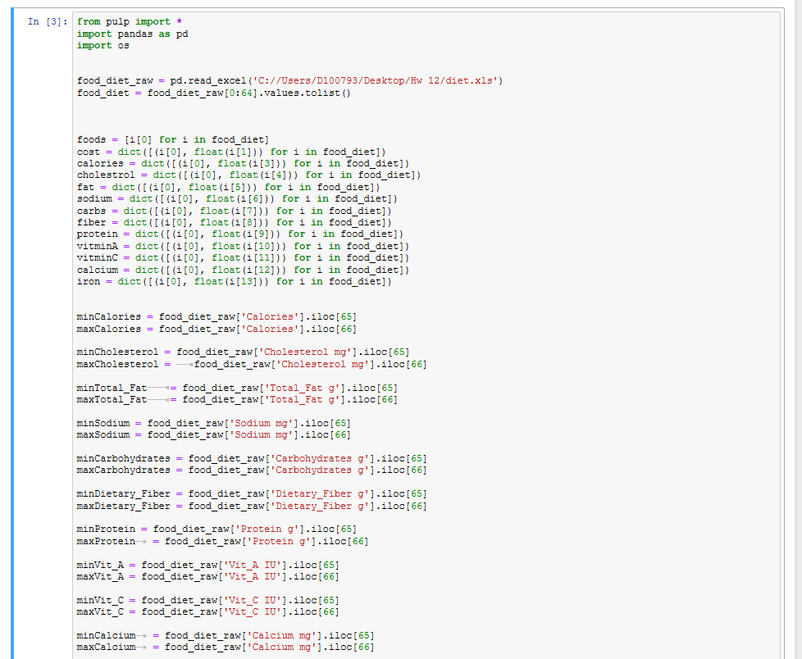

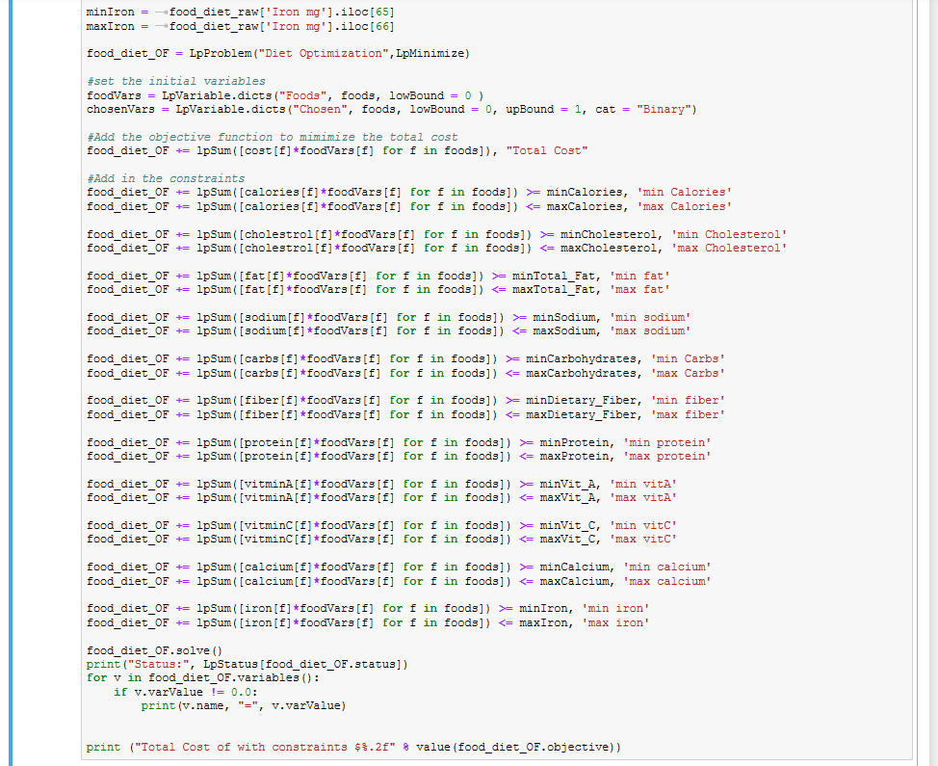

Given below is the output:

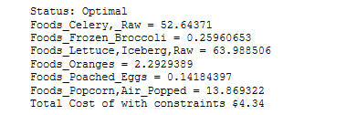

Analysis: Looking at the output above, after adding all the necessary constraints the optimal solution results in a total cost of $ 4.34 per soldier per day.

|  |  |  |  |
| --- | --- | --- | --- |
| **Foods** | **Price Per Serving** | **Serving Qty** | **Cost/ Serving (Price Per Serving * Serving Qty)** |
| Frozen Broccoli | $0.16 | 0.25960653 | $0.04 |
| Celery, Raw | $0.04 | 52.64371 | $2.11 |
| Lettuce,Iceberg,Raw | $0.02 | 63.988503 | $1.28 |
| Oranges | $0.15 | 2.2929389 | $0.34 |
| Poached Eggs | $0.08 | 0.14184397 | $0.01 |
| Popcorn,Air-Popped | $0.04 | 13.869322 | $0.55 |
| **TOTAL** | | | **$4.34** |

**Question 15.2 .1**

In the videos, we saw the “diet problem”. (The diet problem is one of the first large-scale optimization

problems to be studied in practice. Back in the 1930’s and 40’s, the Army wanted to meet the nutritional

requirements of its soldiers while minimizing the cost.) In this homework you get to solve a diet problem with real data. The data is given in the file diet.xls.

Please add to your model the following constraints (which might require adding more variables) and solve the new model:

1. If a food is selected, then a minimum of 1*/*10 serving must be chosen. (Hint: now you willneed two variables for each food *i*: whether it is chosen, and how much is part of the diet.You’ll also need to write a constraint to link them.
2. Many people dislike celery and frozen broccoli. So at most one, but not both, can beselected.
3. To get day-to-day variety in protein, at least 3 kinds of meat/poultry/fish/eggs must be selected. [If something is ambiguous (e.g., should bean-and-bacon soup be considered meat?), just call it whatever you think is appropriate – I want you to learn how to write this type of constraint, but I don’t really care whether we agree on how to classify foods!]

**Answer**: In order to get day to day variety of protein, given below are the foods that I would consider as a good source of proteins

1. Roasted Chicken
2. Frankfurter, Beef
3. Tofu
4. Bologona, Turkey
5. Poached Eggs
6. Scrambled Eggs
7. Ham,Sliced,Extralean
8. Hotdog, Plain
9. Kielbasa,Prk
10. Hamburger W/Toppings
11. Pork
12. Sardines in Oil
13. White Tuna in Water

**CONSTRAINTS**

1. Of all the foods that are chosen, the serving size must be atleast 10 %.
2. If the chosen food has Celery then Broccoli must be avoided or vice versa or both can be avoided.
3. Atleast 3 proteins have to be selected from the chosen protein list.

**OBJECTIVE FUNCTION**

1. Minimize the total consumption cost

Given below is the embedded code for defining building an optimization model with chosen constraints and objective function.

Code:



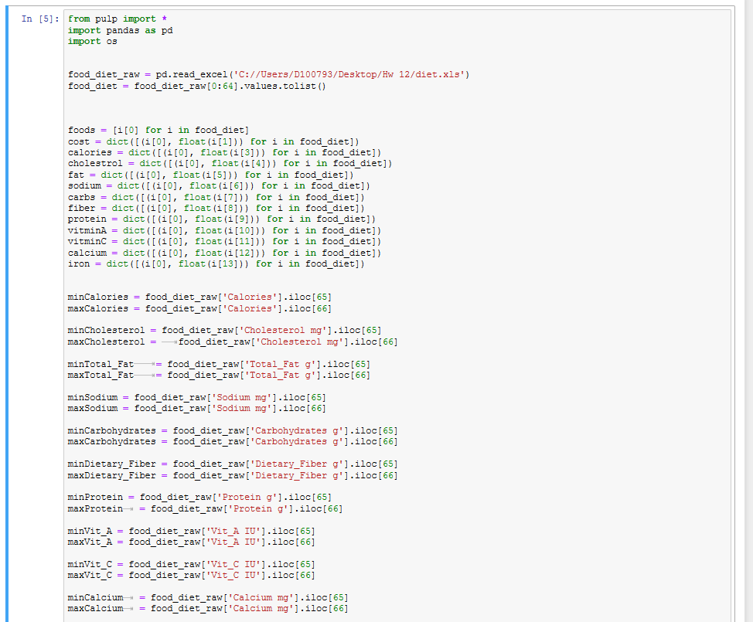

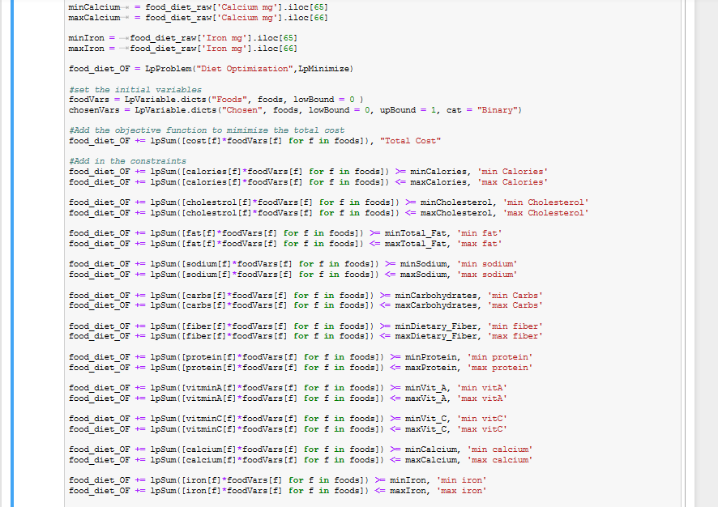

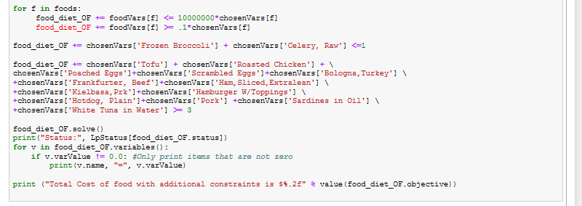

Given below is the output:

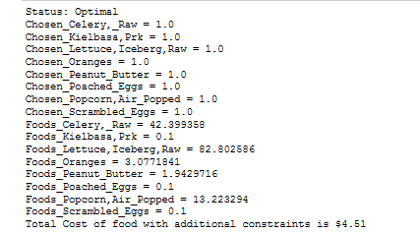

Analysis: With the additional constraints added to the optimization model prepares an optimal solution with a list of 8 food items with 3 protein items and brings the cost to $4.54. The chart below summarizes all the data of the output.

|  |  |  |  |  |  |
| --- | --- | --- | --- | --- | --- |
| **Foods** | **Serving Size** | **Is Protein?** | **Price Per Serving** | **Serving Qty** | **Cost/ Serving (Price Per Serving * Serving Qty)** |
| Celery, Raw | 1 Stalk | No | $0.04 | 42.399358 | $1.70 |
| Lettuce,Iceberg,Raw | 1 Leaf | No | $0.02 | 82.802586 | $1.66 |
| Oranges | 1 Frt,2-5/8 Diam | No | $0.15 | 3.0771841 | $0.46 |
| Poached Eggs | Lrg Egg | Yes | $0.08 | 0.1 | $0.01 |
| Scrambled Eggs | 1 Egg | Yes | $0.11 | 0.1 | $0.01 |
| Kielbasa,Prk | 1 Sl,6x3-3/4x1/16 In | Yes | $0.15 | 0.1 | $0.02 |
| Peanut Butter | 2 Tbsp | No | $0.07 | 1.9429716 | $0.14 |
| Popcorn,Air-Popped | 1 Oz | No | $0.04 | 13.223294 | $0.53 |
| **Total** | | | | | **$4.51** |

* The three proteins chosen were Poached eggs, Scrambled Eggs and Kielbasa, Prk
* The optimal solution chose Celery instead of Broccoli.
* All the serving quantity are atleast 1/10th the serving size.
* A meal for a soldier with chosen constraints of proteins, serving size and choice of Brocolli and Celery costs $4.51 as compared to $ 4.34 without any additional constraints

However for the well being of the soldier with correct nutrition choosing the second optimal solution of $4.51 is recommended as it keeps the soldier in good nutrition for a very small additional cost.